HIMP and SHIMP gains: Camera Placement Experiment – Introduction Summary and Methods

The video Head Impulse Test (vHIT) has emerged as one of the most widely adopted tools in both vestibular clinical practice and research. Its ability to objectively quantify the function of all six semicircular canals through measurement of the vestibulo-ocular reflex (VOR) gain, combined with its quick, non-invasive nature and capacity to detect corrective saccades, has made it an invaluable addition to the vestibular test battery (MacDougall et al., 2009; Halmagyi et al., 2017).
The vHIT is grounded in the physiology of the VOR, a reflex that ensures stable gaze on a visual target during head movement. When the head rotates, endolymph displacement within the semicircular canals activates vestibular hair cells, which transmit signals via primary afferent neurons through the vestibular nerve to the vestibular nuclei in the pontomedullary region. Excitatory projections from these nuclei activate the contralateral lateral rectus and ipsilateral medial rectus muscles while simultaneously inhibiting their antagonists, producing a compensatory eye movement in the direction opposite to head rotation. When this reflex is intact, gaze remains stable on the target. When VOR function is impaired, the eyes fail to compensate adequately for the head movement, necessitating a corrective eye movement back to the target. When this corrective movement occurs after the head impulse has ended, it is termed an overt saccade; when it occurs during the head movement itself, it is termed a covert saccade. The vHIT captures both types of saccades and simultaneously calculates a VOR gain value, defined as the ratio of eye velocity to head velocity, computed at 40, 60, and 80 milliseconds following head movement onset (Korsager et al., 2016).
Normative VOR gain data have been established across several studies and device platforms. Using the EyeSeeCam system, Blöwdow and colleagues reported a mean horizontal VOR gain of 0.96 (SD 0.08) in healthy subjects, with a lower limit of 0.79, while subjects with peripheral vestibular disorders demonstrated a markedly reduced mean gain of 0.44 (SD 0.20). Mossman and colleagues, testing with the ICS Impulse device, reported a mean horizontal VOR gain of 0.94 (SD 0.10) in healthy subjects, with no individual falling below 0.65. The EyeSeeCam manufacturer recommends a gain of 0.70 as the lower limit of normal for the horizontal canals (Interacoustics, 2015), while MacDougall and colleagues proposed a cutoff of 0.68. These normative thresholds are clinically important, as gains falling below these values are interpreted as indicative of canal hypofunction.
While normative data for the horizontal canals are relatively well established, the reliability and accuracy of vertical canal VOR gain measurements have received comparatively less scrutiny. Recent evidence, however, has raised important concerns. Hag and colleagues reported unusually elevated VOR gains of approximately 1.43 and 1.36 for the right anterior and left posterior canals respectively, with test-retest reliability that suggested these were not random artifacts. Critically, the asymmetry between canal pairs exceeded 30%, a magnitude that would be considered highly abnormal in clinical practice. Cadervall and colleagues similarly reported gains as high as 1.43 for the eye over which the camera was positioned, with asymmetries exceeding 33%. Importantly, when the camera position was reversed using the functionality available within the Interacoustics system, the asymmetry reversed accordingly, strongly implicating monocular camera placement as the source of the inflated vertical canal gains. If such artificially elevated gains are recorded in clinical populations, true vestibular hypofunction may be masked, resulting in a systematic underestimation of pathology and an elevated rate of false-negative findings.
Despite these observations, the extent and consistency of this camera placement effect has not been systematically characterized. The present study therefore aimed to (1) assess the test-retest reliability of vertical canal VOR gains recorded with the EyeSeeCam system, and (2) determine whether monocular camera placement over the right versus left eye introduces a systematic bias in vertical canal VOR gain measurement for both the Head Impulse Paradigm (HIMP) and the Suppression Head Impulse Paradigm (SHIMP).
One potential but insufficiently studied source of variability is monocular camera placement. The EyeSeeCam system utilizes a single high-speed camera mounted over one eye to estimate eye velocity during head impulses. Because vertical canal responses involve combined vertical and torsional eye movement components, monocular recording geometry may differentially influence VOR gain estimation across canal planes. However, the extent to which camera placement systematically affects vertical canal VOR gain measurements has not been formally evaluated.
During initial familiarization testing with the EyeSeeCam system, we observed consistently elevated VOR gains in the right anterior and left posterior canals when the camera was positioned over the right eye. This observation prompted further investigation into whether the effect was reproducible and whether gain inflation systematically shifted with camera placement. Therefore, the objectives of the present study were: (1) to evaluate the test–retest reliability of these elevated vertical canal VOR gains across separate sessions, and (2) to determine whether monocular camera placement systematically influences vertical canal VOR gain measurements during both HIMP and SHIMP testing. We hypothesized that camera placement would produce a consistent, direction-dependent bias in vertical canal VOR gain estimates.

Methods
Participants
Twenty healthy adult females were recruited via convenient sampling. Five participants were unable to complete both test sessions and were therefore excluded, leaving a final sample of 15 participants (age range: 21–33 years). All participants reported no history of vestibular disorders, neurological conditions, or ear pathology. Ethical approval for this study was granted by the Institutional Review Board (IRB) at the University, and written informed consent was obtained from all participants prior to participation.
Equipment
All recordings were made using the EyeSeeCam video Head Impulse Test system (Interacoustics, Middlefart, Denmark), a monocular high-speed camera system that quantifies VOR gain by recording eye velocity relative to head velocity during brief, unpredictable head impulses.
Procedure
Testing was conducted in a dedicated clinic room with participants seated one meter from a fixed visual target. The same trained examiner performed all testing across both sessions to minimize inter-examiner variability. Participants were instructed to maintain fixation on the target throughout each head impulse.
For each test session, HIMP testing was first performed with the camera positioned over the right eye, followed by a second run with the camera repositioned over the left eye. This camera placement order was kept consistent across both sessions. Vertical canal impulses were delivered in the LARP (Left Anterior–Right Posterior) and RALP (Right Anterior–Left Posterior) planes, with the 45° oblique plane guided by the polar plot laser within the EyeSeeCam software. A minimum of 15 acceptable head impulses were collected per canal per run. Target head velocity was greater than 150°/s for the horizontal canals and greater than 100°/s for the vertical canals, consistent with published recommendations for vertical canal vHIT acquisition.
Test-Retest Protocol
The identical protocol was repeated seven days later to assess test-retest reliability. The one-week interval was selected to minimize carry-over effects while remaining within a timeframe over which vestibular function would not be expected to change in healthy participants.
Data Analysis
VOR gain values for all six semicircular canals were extracted from the EyeSeeCam software for each run. To quantify the effect of camera placement, difference scores were computed by subtracting VOR gain obtained with the camera on one eye from that obtained with the camera on the opposite eye. Specifically, for right-sided canals (right lateral, right anterior, right posterior), the difference was calculated as gain with the camera on the right eye minus gain with the camera on the left eye; for left-sided canals (left lateral, left anterior, left posterior), the difference was calculated as gain with the camera on the left eye minus gain with the camera on the right eye. Test-retest reliability was assessed using intraclass correlation coefficients (ICC) with 95% confidence intervals, and camera placement effects were examined using paired samples t-tests. Statistical significance was set at p < 0.05.

Background: We recently acquired the EyeSeeCam video Head Impulse Test (vHIT) system (Interacoustics, Middlefart, Denmark), which uses a monocular high-speed camera to quantify vestibulo-ocular reflex (VOR) gain. During initial familiarization testing, we observed abnormally elevated VOR gains in the vertical canals. This observation was noted for 5 participants (figure 1) prompting a systematic investigation into the reliability of these findings and the potential effect of camera placement.
Initial Observation: Pilot HIMP testing was conducted in five participants with the camera and accelerometer positioned over the right eye. In these initial recordings, VOR gains were unusually high for the right anterior (RA) and left posterior (LP) semicircular canals. The table below shows the findings for the initial observation. These unexpected findings motivated further evaluation.
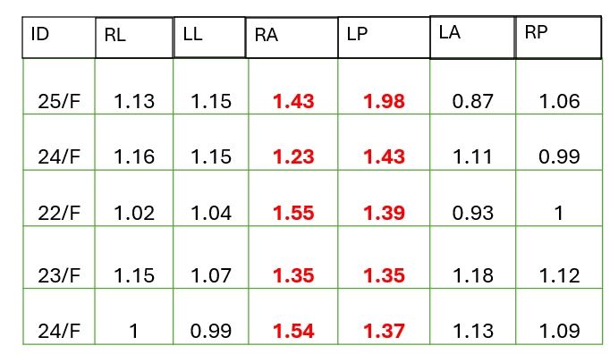
Study Objective: The primary objectives of this experiment were (1) to assess test–retest reliability of the observed vertical canal VOR gains and (2) to determine whether camera placement (right vs. left eye) systematically influenced vertical canal VOR measurements for HIMP and SHIMP.
Methods:
A reliability protocol was developed incorporating both Head Impulse Paradigm (HIMP) and Suppression Head Impulse Paradigm (SHIMP) testing. On the first test day, HIMP Run 1 was recorded with the camera placed on the right eye, followed by HIMP Run 2 with the camera placed on the left eye. SHIMP testing was conducted using the same order of camera placement. The identical protocol was repeated seven days later to assess test-retest reliability.
Results:
- The data demonstrated strong test–retest reliability across the two sessions. When the camera was placed on the right eye, abnormally elevated VOR gains were consistently observed for the RA and LP canals (Figure 2).
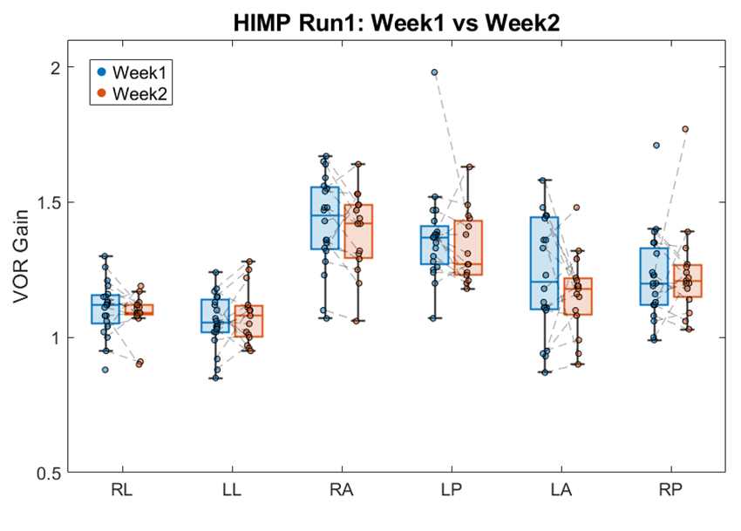
Figure 2: The camera placed on the right eye. The two recordings are done one week apart.

- When the camera was placed on the left eye, elevated VOR gains shifted to the left anterior (LA) and right posterior (RP) canals. This pattern was consistent across both weeks.

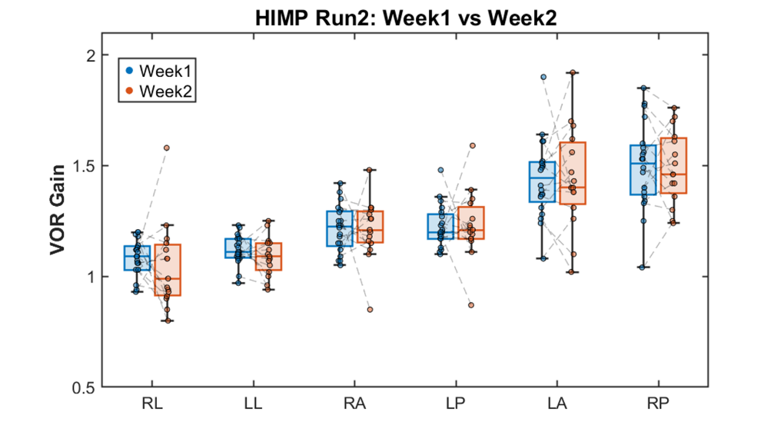
Figure 3. The camera placed on the right eye. The two recordings are done one week apart.
- Direct comparison of VOR gain by camera placement showed that positioning the camera over one eye selectively increased VOR gain in the anterior canal on that side and the contralateral posterior canal. This effect was observed for both HIMP and SHIMP paradigms. See Figure 4 and Figure 5.
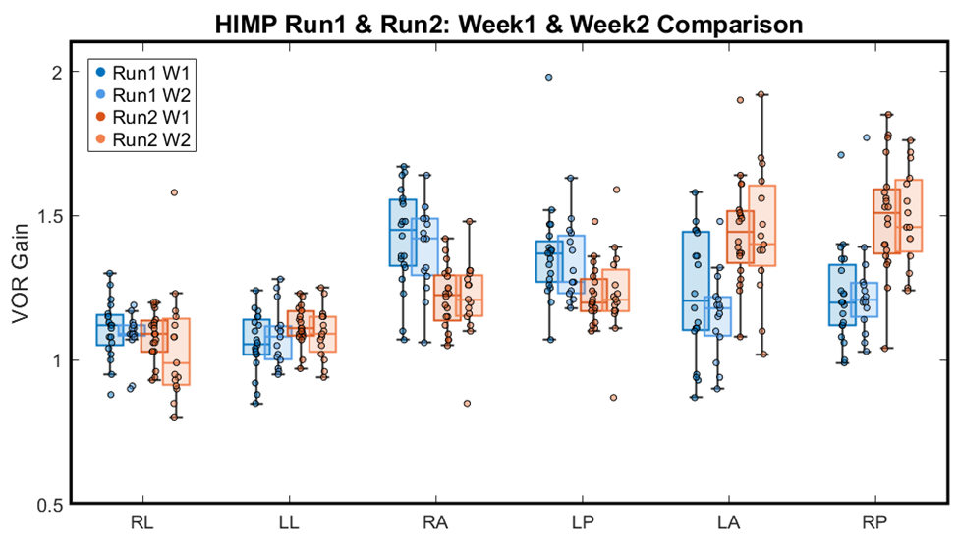
Figure 4. HIMP gains across two weeks. The blue box-plot is when the camera was placed on the right eye. The orange box-plot is when the camera was placed on the left eye.

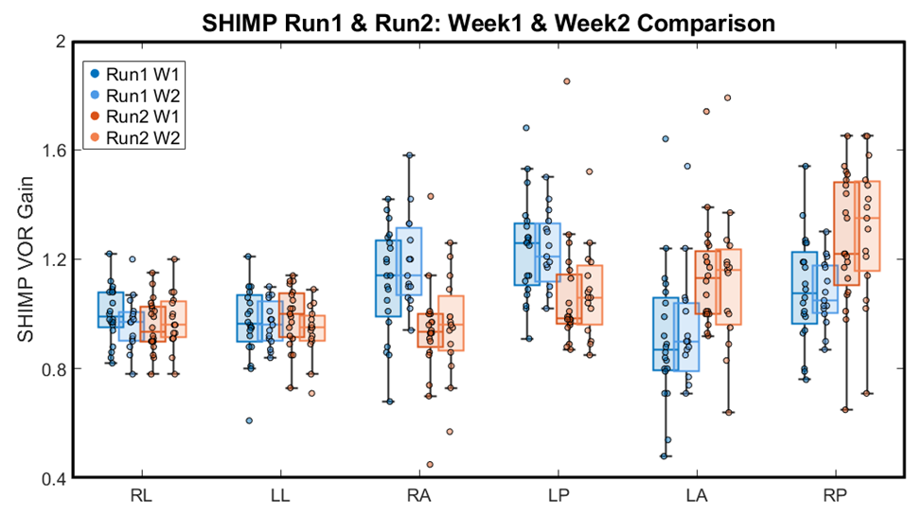
Figure 5. SHIMP gains across two weeks. The blue box-plot is when the camera was placed on the right eye. The orange box-plot is when the camera was placed on the left eye.

- Difference scores (right-eye placement minus left-eye placement and vice versa) revealed a mean increase in VOR gain of approximately 0.25 units. Notably, this camera placement effect was specific to the vertical canals; horizontal canal gains were not similarly affected. Figure 6. Shows the difference
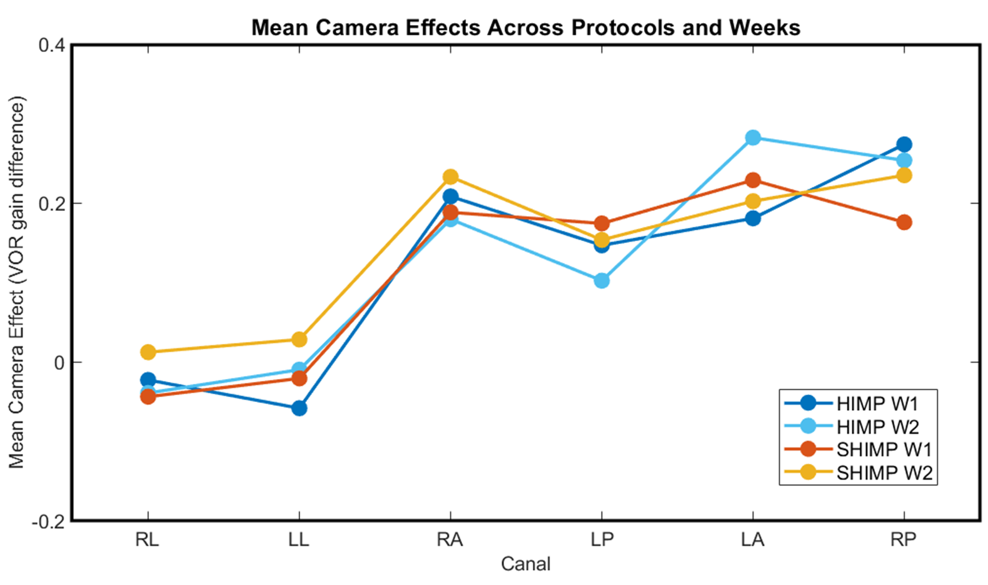
Figure 6. The difference in the VOR gain as an effect of camera placement. Specifically, difference scores were computed as follows: for right-side measures (right lateral [RL], right anterior [RA], and right posterior [RP]), VOR gain with the camera on the right eye minus VOR gain with the camera on the left eye; for left-side measures (left lateral [LL], left anterior [LA], and left posterior [LP]), VOR gain with the camera on the left eye minus VOR gain with the camera on the right eye.

Conclusion:
These findings suggest that monocular camera placement in the EyeSeeCam system introduces a systematic bias in vertical canal VOR gain, selectively inflating gains in specific canal pairs. The strong test-retest reliability indicates that this effect is consistent rather than random, highlighting an important methodological consideration for vertical canal vHIT acquisition and interpretation. Clinically, this gain inflation may mask true vestibular hypofunction in pathological populations, increasing the risk of false-negative interpretations for vertical canal deficits.

